Feng Chia University

Electrical Engineering Fundamentals II Lab

Laboratory 10

BJT Amplifier Circuits - VTC Measurement

Instructor: Prof. Shyan-Lung Lin

Student Name: 周嘉禾

Student ID: D1166506

Experiment Date:16/05/2024

1. Introduction
2. To observe the behavior of BJT amplifier circuits.
3. Materials
   1. Power supply
   2. Function generator
   3. Oscilloscope
   4. Devices

Q: 2SC1815 ×1

Resistors: R = 5.6 kΩ ×1, 1.2 kΩ ×1, 33 kΩ ×1, 10 kΩ ×3, 20 kΩ ×3

1. Circuit diagram

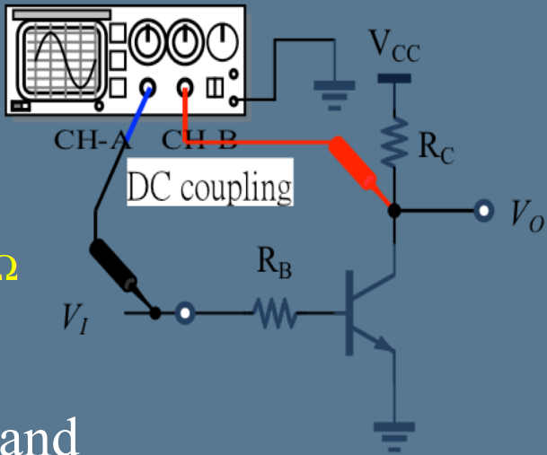

▲ Figure 1. Circuit of Experiment 10.a Basic BJT Circuits without Emitter

Resistor

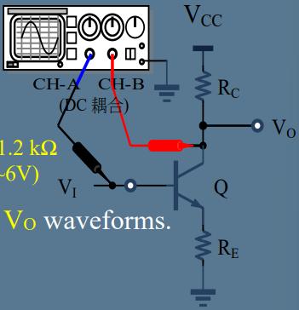

▲ Figure 2. Circuit of Experiment 10.b Basic BJT Circuits with Emitter Resistor

1. Methods

Using Oscilloscope to observe voltage.

1. Experiments data
   1. Experiment 10.a Basic BJT Circuits without Emitter Resistor

Table 1: Measurement of BJT without Emitter Resistor

|  |  |  |  |  |  |
| --- | --- | --- | --- | --- | --- |
|  | VIA | VIB | VOA | VOB | AV |
| Measurement | 0.4 V | 0.9 V | 12 V | 0 V | 24.0000 |
| Theoretical | 0.7 V | 0.945 V | 12 V | 0.3 V | 47.7551 |

* 1. Experiment 10.b Basic BJT Circuits with Emitter Resistor

Table 2: Measurement of BJT with Emitter Resistor

|  |  |  |  |  |  |
| --- | --- | --- | --- | --- | --- |
|  | VIA | VIB | VOA | VOB | AV |
| Measurement | 0.5 V | 2.5 V | 12 V | 2 V | 5.0000 |
| Theoretical | 0.7 V | 2.9344 V | 12 V | 2.5344 V | 4.2363 |

1. Results

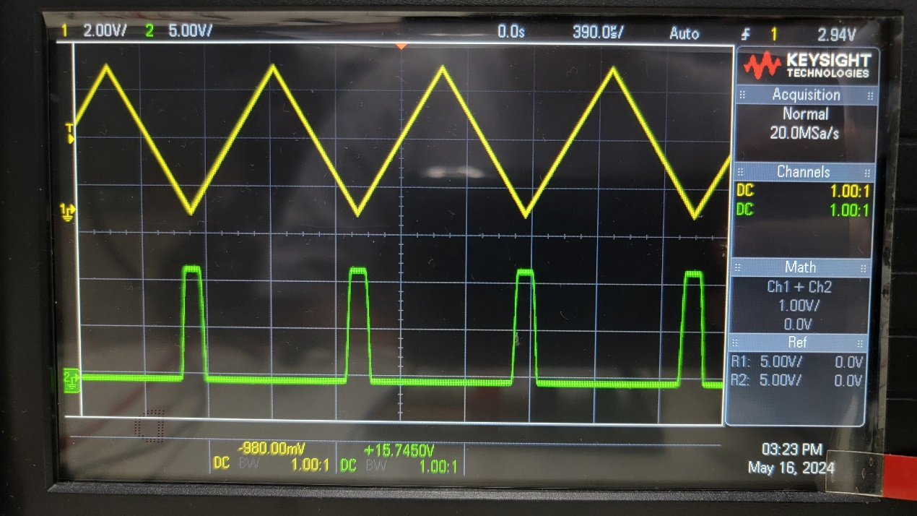

▲ Figure 3. VTC curve of Experiment 10.a

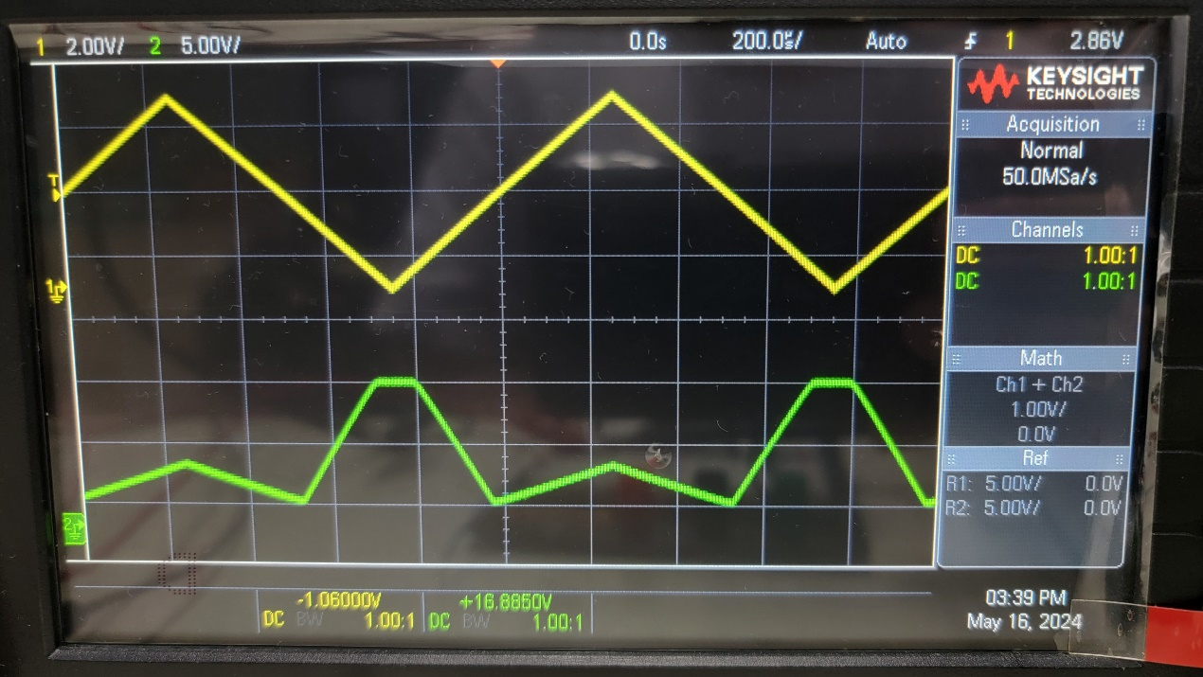

▲ Figure 4. VTC curve of Experiment 10.b

1. Discussion
   1. Compare the VTC curves from the Experiment 10.a and 10.b (with/without RE) for the differences and the similarities.

Both of them had the peaks in VO when VI reached valleys. Furthermore, the BJT with emitter resistor had a bent curve. However, BJT without emitter resistor had a smooth curve.

* 1. Based on the experiment results from 10.a and 10.b, try to derive the conclusions on the effect of RE with following issues:
     + Effect on Voltage gain of linear amplifier region AV, and why?

The Early voltage decreases the transistor’s current gain B.

Lower B due to the Early effect results in reduced voltage gain AV in the linear amplifier region.

* + - Effect on Switching (ON) region, and why?

The Early voltage affects base current IB and collector current IC.

Higher VRE values can lead to slower switching times due to reduced IC

1. Conclusion

From the experimental data above, the BJT work in an ideal situation.